M-O / NORTHERN LAKES / PACKERLAND CONFERENCE
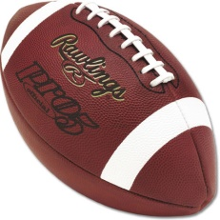
FOOTBALL - LARGE SCHOOL DIVISION
STANDINGS
OCTOBER 11, 2019

SCHOOL WON LOST TIED
Kewaunee 4 0 0
Peshtigo 4 0 0
Southern Door 2 3 0
Oconto 1 3 0
Sturgeon Bay 0 3 0

