PACKERLAND CONFERENCE
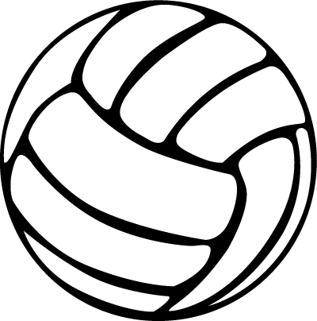
2021 ALL-CONFERENCE VOLLEYBALL TEAM

1ST TEAM
NAME SCHOOL YEAR POSITION
Bailey Rikkola Sevastopol Junior Libero Unanimous
Kate Bahrke Oconto Junior Setter Unanimous
Lianna Baxter Oconto Senior All-Around Unanimous
Hannah Moe Oconto Senior All-Around Unanimous
Madilyn Volkmann Sevastopol Senior All-Around
Cate Anderson Sturgeon Bay Junior Front Row
Johanna Andreae Sevastopol Junior Front Row
Greta Wise NEW Lutheran-Providence Junior All-Around
Samantha Kodric Peshtigo Senior Front Row

2ND TEAM
NAME SCHOOL YEAR POSITION
Tori Jandt Peshtigo Senior Libero
Emma Stueber Sevastopol Junior Setter
Leah Schmidt NEW Lutheran-Providence Senior Front Row
Allianna Dufek Southern Door Junior Front Row
Kendra Shimon Southern Door Freshman Front Row
Mykenzi Uhlers Kewaunee Senior Front Row
Nida Zukauskaite Gibraltar Sophomore All-Around
Anna Olson Southern Door Senior Libero

HONORABLE MENTION
NAME SCHOOL YEAR POSITION
Mylee Jones Algoma Freshman All-Around
Toni Bortolini Kewaunee Senior All-Around
Allison Peters Peshtigo Junior All-Around
Samantha Differt Sevastopol Senior All-Around
Emily Ulberg Sturgeon Bay Senior All-Around
Rylee Fenendael Algoma Senior Front Row
Lexi Dhein NEW Lutheran-Providence Sophomore Libero
McKenna Seidl Oconto Senior Libero
Emma Reichel Sturgeon Bay Senior Libero
Leah Allan Oconto Senior Back Row
Emma Gilligan Peshtigo Senior Setter
Alaina Shimon Southern Door Freshman Setter
Hannah Sternard Styrgeon Bay Senior Setter

PLAYER OF THE YEAR
NAME SCHOOL YEAR POSITION
Lianna Baxter Oconto Senior All-Around

